|  |  |  |
| --- | --- | --- |
|  |  |  |

GOVERNMENT OF INDIA

**MINISTRY OF SKILL DEVELOPMENT & ENTREPRENEURSHIP**

DIRECTORATE GENERAL OF TRAINING

**NATIONAL SKILL TRAINING INSTITUTE**

NSTI Campus, Chunabhatti, Sion(E) Mumbai-400022

**CERTIFICATE**

This is to certify that following trainees have completed their project titled

**“NSTI Smart Cloud Campus”**

**For IBM Program – IT, Networking and Cloud (Technical Diploma)**

|  |  |
| --- | --- |
| **ROLL NO** | **NAME** |
| ADIT19AU00243 | Sudha kumari Das |
| ADIT19AU00537 | Niharika singh |

|  |  |  |
| --- | --- | --- |
|  |  |  |
|  |  |  |

**ACKNOWLEDGEMENT**

We would like to express my sincere gratitude to several individuals and organizations for supporting me throughout my diploma study. First, I wish to express my sincere gratitude to my trainer, Mr.Boddu Lingian and Miss Arpita Roy, for his enthusiasm, patience, insightful comments, helpful information, practical advice and unceasing ideas that have helped me tremendously at all times in my study and writing of this project report. His immense knowledge, profound experience and professional expertise in computer science has enabled me to complete this project successfully.

I also wish to express my sincere thanks to the National Skill Training Institute, Mumbai for accepting me into the diploma program. In addition, I am deeply indebted to the Ministry of Skill Development & Entrepreneurship and IBM for granting me the diploma course. This technical and financial support has enabled me to complete my diploma course studies successfully. Also, I am grateful to Miss. Trupti Pawar faculty of NSTI Mumbai for supporting me for course completion in the specific subject.

I am also grateful to the following NSTI Regional Director Sir Mr. S. Harinath Babu and Assistant Director Sir Mr. Gulab Chandra for their consistent support and assistance.

ABSTRACT

Our project is a fruit website. This is a website which helps people to find and buy all types of Fruits.

It is useful in the way that it makes an easier way to buy and sell fruits online.

This website is an interactive solution providing users with an opportunity to buy and sell fruits.

Fruit kart is an online platform which deals with all types of fruits.

In this website we have basically 2 Modules the customer module and the second module include the admin module.

The customer has to register for any enquiry related to fruits.

The registered customer can view details of fruits and he/ she can buy or sell the fruits of his/her need.

.

INDEX

|  |  |  |
| --- | --- | --- |
| Sr. No. | Table of Contents | Page No. |
| 1 | Chapter 1: Introduction | 5-8 |
| 2 | Chapter 2: Services and Tools Required | 9-12 |
| 3 | Chapter 3: Project Architecture | 12 |
| 4 | Chapter 4: Architecture Blocks Detail Working | 13-14 |
| 5 | screenshot | 16-20 |
| 6 | code | 21-37 |
| 7 | conclusion | 38 |
| 8 | Reference | 39 |

CHAPTER-1

1.1 INTRODUCTION:

A web application (or web app) is application software that runs on a webserver, unlike computer-based software programs that are run locally on the operating system (OS) of the device. Web applications are accessed by the user through a web browser with an active network connection. These applications are programmed using a client-server modeled structure—the user ("*client*") is provided *services* through an *off-site server* that is hosted by a third-party. Examples of commonly-used web applications include: web mail, online retail sale, online banking, and online auctions.

In 2005, the term Ajax was coined, and applications like Gmail started to make their client sides more and more interactive. A web page script is able to contact the server for storing/retrieving data without downloading an entire web page.

In 2007, Steve jove announced that web apps, developed in HTML 5 using AJAX architecture, would be the standard format for iphone apps.

Through HTML, Java script, CSS,Flash, Silverlight and other technologies, application-specific methods such as drawing on the screen, playing audio, and access to the keyboard and mouse are all possible. Many services have worked to combine all of these into a more familiar interface that adopts the appearance of an operating system.

Applications are usually broken into logical chunks called "tiers", where every tier is assigned a role.web applications are often simplified by the use of web application frameworks. These frameworks facilitate Rapid application development by allowing a development team to focus on the parts of their application which are unique to their goals without having to resolve common development issues such as user management.

1.2 OVERVIEW:

Fruit kart web application is a very useful application. It is work on

all browsers. Customer and seller know about all information by this

application. He/she knows the different types of fruits. They easily

contact with their seller and buyer through the message and blog

system. We provide different types of facilities by this application.

Users are always satisfied using this application. in this application

home, contact and message systems.

1.3 FEATURES:

This web application work on all types of browsers.It is user frie

ndly. we use HTML, CSS, Java scripts and other programing lang

uage. We used a step by step process to make this web applicati

on. This application provide many information price, different

types of fruits. We added home page, blog, and contact and oth

ers different items. He/she send messages by this application and

These messages are saved on our database. Then we know custo

mers queries. They contact our phone no and via mail system.

1.4 ADVANTAGES:

1.Zero install- all pcs have a browsers

2.Reduces business costs- less time spent talking to customers

over the phone eliminated materials, allow users to update theirs

details.

3.centralised data is secure and easy to backup.

4. reach anybody, anywhere in this world.

5.Available 24 hours a day, 7 days a week.

6.Low spec PCs or smartphones can be used.

7.Direct access can be completed at the user's own time and place.

8.Always up-to-date.

1.5 SCOPE:

project scope planning is immensely important project management and sometimes be seen as complex topic that up alot and these are the

following some scopes:

1 Requirements: fruits kart web application give many types of requirements like blogs, messaging system, subscribe and email

systems. we works for our future requirements that make this

more comfortable and reliable for our users.

2.roles and responsibilities:

All our team members work daily for this web application.they

changed many of features thats makes its comfortable for our

users.we gave a special name for this website “fruits kart”. this

The name indicates our web application is unique and attractive.our shop name is jof fruits shop.every members did their work on time.

all work divided by section and each group.

3. stakeholder Acceptance:

before finalising the project management for the “fruits kart” web

design, the client(jof shop) and other pertinent stakeholder review

along with the project manager and/or team the formulated scope

to make sure that everyone is in agreeance in terms of what the

application is complete or not.

1.6 Future work:

The application can be easily implemented under various situation

s. We can add new features as and when we require.Reusability is

possible as and when required in this application. this is flexibility

all the modules. the software is extendable in ways that its original

developers may or not. We can update it in the next version. sharing

of newly written code within a project.

CHAPTER-2

SERVICES AND TOOLS

REQUIRED

2.1 SERVICES USED:

web application are made by differents types of programming

languages,services, and others tools. Here we using some few

programming languages.

2.1.1 HTML:

The HyperText Markup Language, or HTML is the standard markuplanguage for documents designed to be displayed in a web browser. It can be assisted by technologies such as cascading style sheets(CSS) and scripting languages such as java scripts.Web browsers receive HTML documents from a web server or from local storage and render the documents into multimedia web pages.HTML are the building blocks of HTML pages. With HTML constructs images and other objects such as interactive forms may be embedded into the rendered page. HTML provides a means to creatstructred documents by denoting structural semantics for text such as headings, paragraphs, lists,links, quotes and other items. HTML elements are delineated by *tags*.

2.2. TOOLS AND SOFTWARES USED:

2.2.1 NODEJS:

Node.js is open source, cross platform, back-end javascript runtimeenvironment that runs on the V8engine and executes JavaScript code outside a web browser. Node.js lets developers use JavaScript to write command line tools and server side scripting —running scripts server-side to produce dynamic web page content before the page is sent to the user's web browser. Consequently, Node.js represents a "JavaScript everywhere" paradigm..js is the standard filenameextension for JavaScript code, the name "Node.js" doesn't refer to a particular file in this context and is merely the name of the product. Node.js has an event-drivenarchitecture capable of asynchronous. These design choices aim to optimize throughput and scalability in web applications with many input/output operations, as well as for real-timeweb applications.

2.2.2 MONGODB:

MongoDB is a document database with the scalability and flexibility that you want with the querying and indexing that you need.

* MongoDB stores data in flexible, JSON-like documents, meaning fields can vary from document to document and data structure can be changed over time
* Ad hoc queries, indexing, and real time aggregation provide powerful ways to access and analyze your data
* The document model maps to the objects in your application code, making data easy to work with
* MongoDB is a distributed database at its core, so high availability, horizontal scaling, and geographic distribution are built in and easy to use
* MongoDB is free to use. Versions released prior to October 16, 2018 are published under the AGPL. All versions released after October 16, 2018, including patch fixes for prior versions, are published under these server side public License(sspl).

*important technologies*

*programming languages*

*HTML,CSS,Javascript, boot stratrap*

*runtime environment-nodejs*

*Tools used*

operating system- window 10

mongodb

*Hardware used*

processor-intel core i3

RAM-4GB

Hard Disk-1tb

* TESTING:

their testing in several ways, which may result in harder than traditional application testing. Suitable methods and techniques have to be defined and used to test Web applications effectively. This chapter will present the main differences between Web applications and traditional ones, and how these differences impact the testing of Web applications. It also discusses relevant contributions in the field of Web application testing, proposed recently. The focus of the chapter is mainly on testing the functionality of a Web application, although discussions about the testing of non-functional requirements are provided too.

CHAPTER-3

PROJECT ARCHITECTURE

3.1 Architecture

USER FRONTEND BACKEND

|  |  |  |
| --- | --- | --- |
| User Internet | HTML 5Web design | NODEJS 14.0Node.js JavaScript npm Computer Icons Web application, text, logo png |  PNGEgg    DatabaseCloudant - Crunchbase Company Profile &amp; Funding |

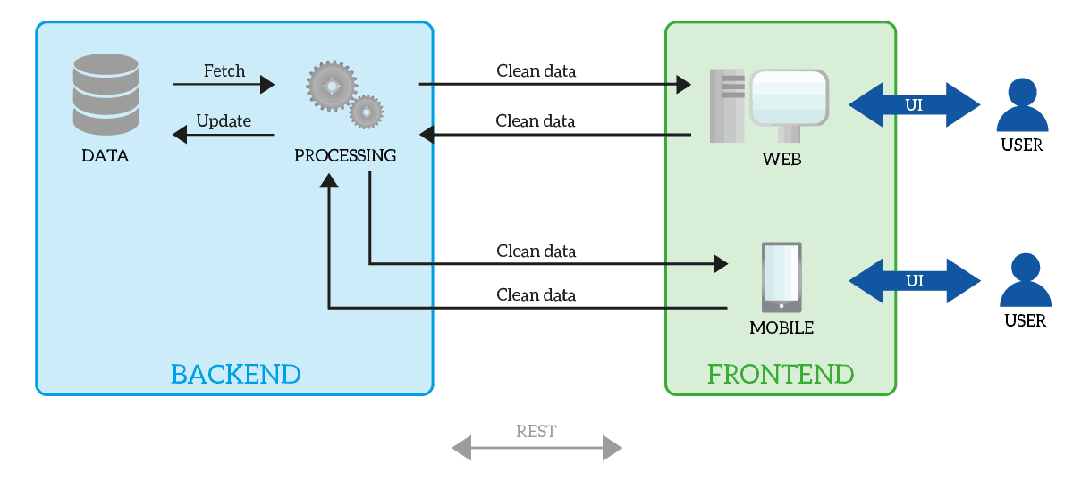

CHAPTER 4

ARCHITECTURE BLOCKS DETAIL WORKING

1.1DATA FLOW DIAGRAM:

DFD, Data flow diagrams are used to graphically represent the flow of data in a business information system. DFD describes the processes that are involved in a system to transfer data from the input to the file storage and reports generation.

Data flow diagrams can be divided into logical and physical. The logical data flow diagram describes flow of data through a system to perform certain functionality of a business. The physical data flow diagram describes the implementation of the logical data flow.

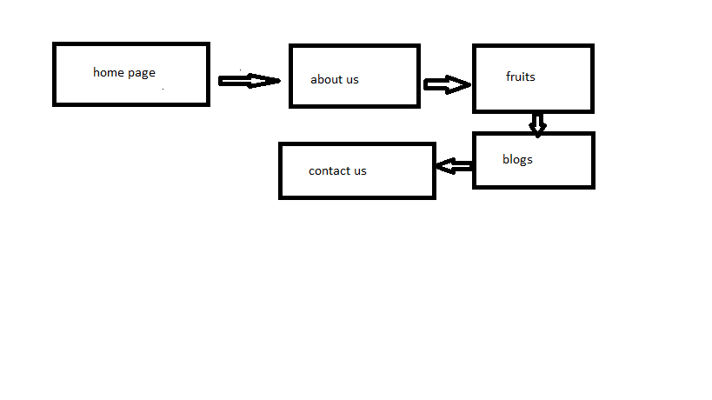

1.2 E R DIAGRAM:

An entity relationship diagram (ERD), also known as an entity relationship model, is a graphical representation that depicts relationships among people, objects, places, concepts or events within an information technology (IT) system. An ERD uses data modeling techniques that can help define business processes and serve as the foundation for a relational database.

Entity relationship diagrams provide a visual starting point for database design that can also be used to help determine information system requirements throughout an organization. After a Relationaldatabase is rolled out, an ERD can still serve as a reference point, should any debugging or business process re-engineering be needed later.

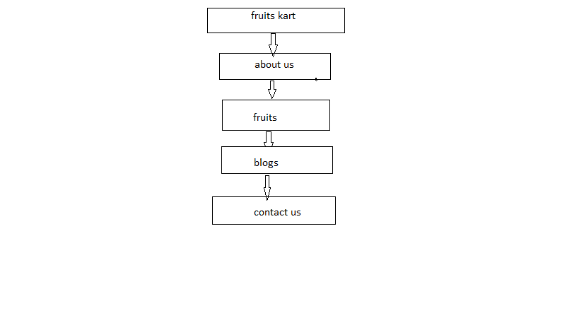

We follow some steps for made web application:

Step1:

open the folder and write cmd over open it.

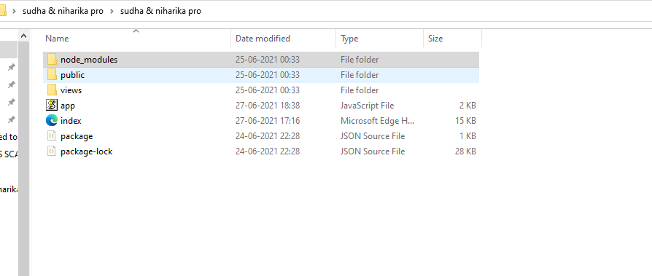

step:2

open command prompt and write node app.js and connect with

mongo db .

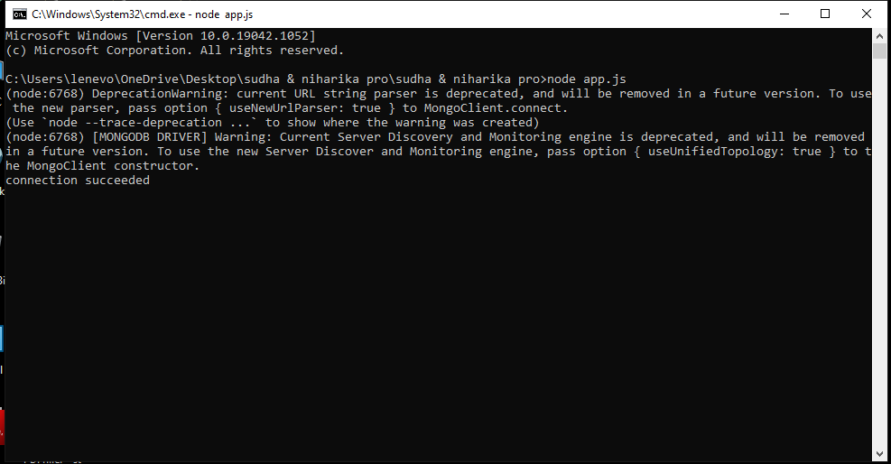

step:3

open chrome and type’’localhost:3030’’ and check it works or not.

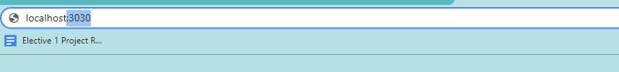

step:4

its works and shows the front page of our website.

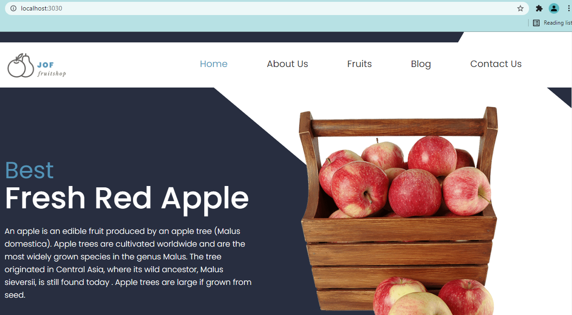

step:5

We open our website and check all the functions. 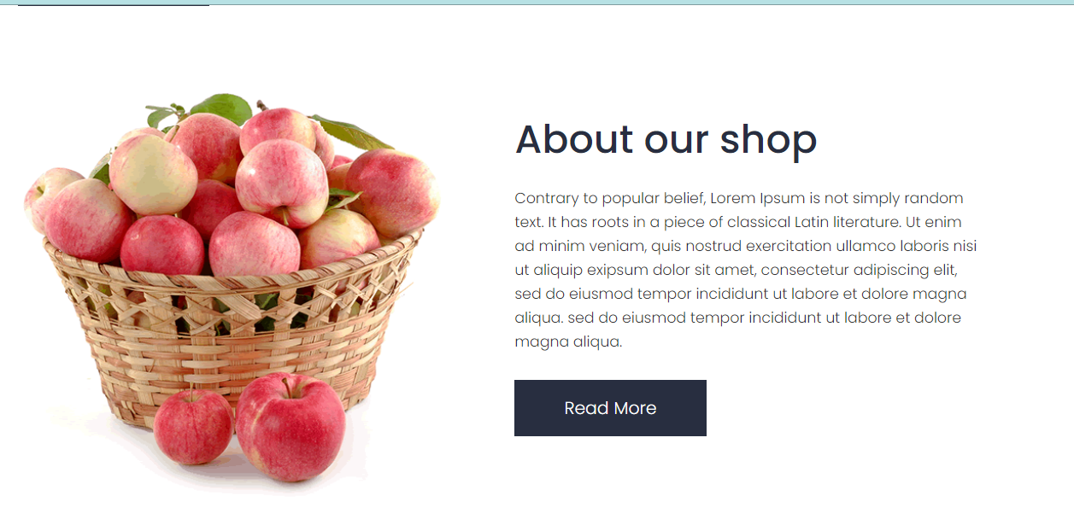

step:6

this is website pages

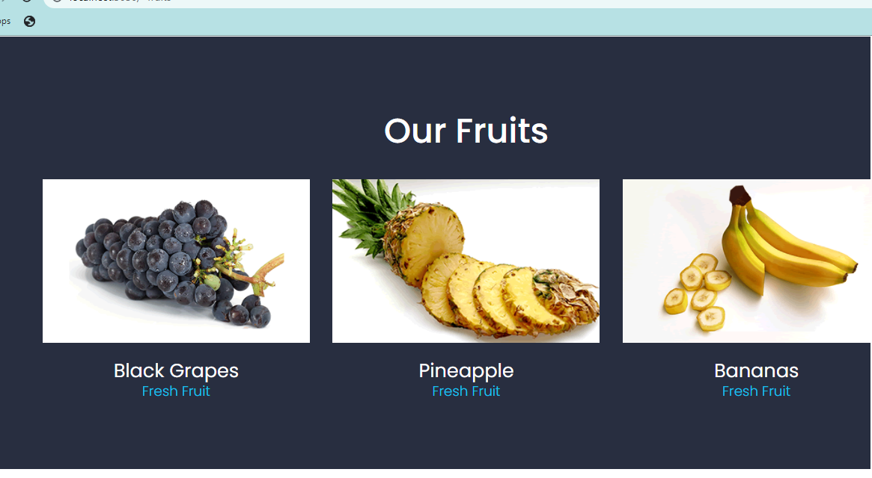

this is blogs pages, user read our blogs

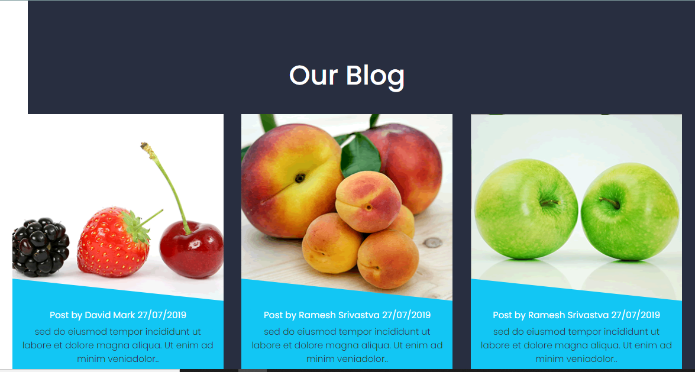

this is contact us pages user write our messages and send it.

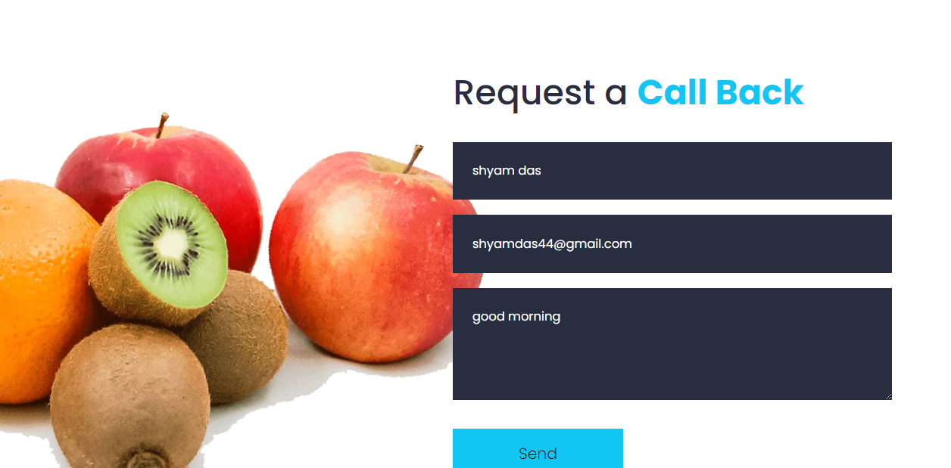

open mongo db and we check the users messages stored in our database.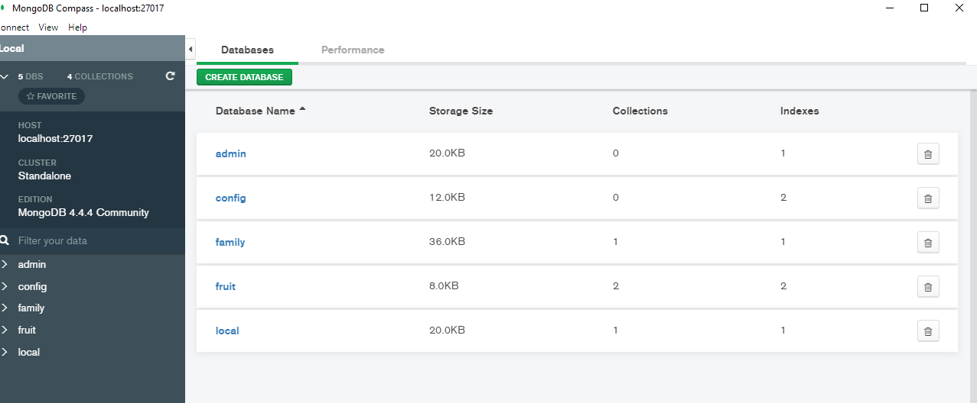

the message shows in our mongodb database. messages show then

It rightly showed an error then some problem.

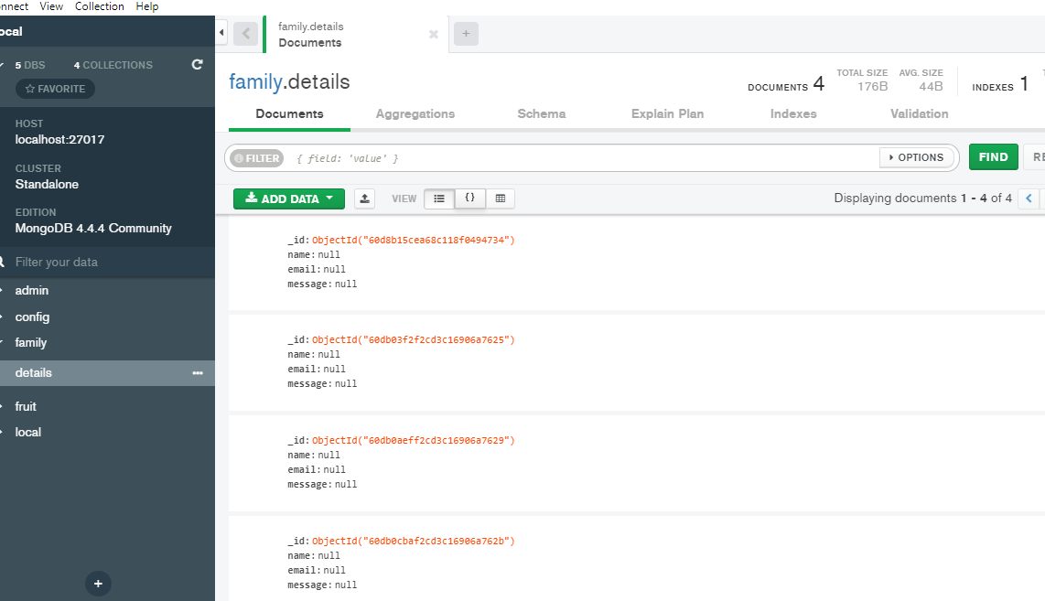

COde:

index .html

!DOCTYPE html>

<html lang="en">

<head>

<!-- basic -->

<meta charset="utf-8">

<meta http-equiv="X-UA-Compatible" content="IE=edge">

<!-- mobile metas -->

<meta name="viewport" content="width=device-width, initial-scale=1">

<meta name="viewport" content="initial-scale=1, maximum-scale=1">

<!-- site metas -->

<title>Fruits kart</title>

<meta name="keywords" content="">

<meta name="description" content="">

<meta name="author" content="">

<!-- bootstrap css -->

<link rel="stylesheet" href="css/bootstrap.min.css">

<!-- style css -->

<link rel="stylesheet" href="css/style.css">

<!-- Responsive-->

<link rel="stylesheet" href="css/responsive.css">

<!-- fevicon -->

<link rel="icon" href="images/fevicon.png" type="image/gif" />

<!-- Scrollbar Custom CSS -->

<link rel="stylesheet" href="css/jquery.mCustomScrollbar.min.css">

<!-- Tweaks for older IEs-->

<!--[if lt IE 9]>

<script src="https://oss.maxcdn.com/html5shiv/3.7.3/html5shiv.min.js"></script>

<script src="https://oss.maxcdn.com/respond/1.4.2/respond.min.js"></script><![endif]-->

</head>

<!-- body -->

<body class="main-layout">

<!-- loader -->

<div class="loader_bg">

<div class="loader"><img src="images/loading.gif" alt="#" /></div>

</div>

<!-- end loader -->

<!-- header -->

<header id="home">

<!-- header inner -->

<div class="header">

<div class="container">

<div class="row">

<div class="col-xl-3 col-lg-3 col-md-3 col-sm-3 col logo_section">

<div class="full">

<div class="center-desk">

<div class="logo"> <a href="index.html"><img src="images/logo.png" alt="#"></a> </div>

</div>

</div>

</div>

<div class="col-xl-9 col-lg-9 col-md-9 col-sm-9">

<div class="menu-area">

<div class="limit-box">

<nav class="main-menu">

<ul class="menu-area-main">

<li class="active"><a href="#home">Home</a></li>

<li><a href="#about">About Us</a></li>

<li><a href="#fruits">Fruits</a></li>

<li><a href="#blog">Blog</a></li>

<li><a href="#contact">Contact Us</a></li>

</ul>

</nav>

</div>

</div>

</div>

</div>

</div>

</div>

<!-- end header inner -->

</header>

<!-- end header -->

<section class="slider_section">

<div class="container">

<div class="row">

<div class="col-md-6">

<div class="full">

<h1><strong class="cur">Best</strong><br>Fresh Red Apple</h1>

<p>An apple is an edible fruit produced by an apple tree (Malus domestica).

Apple trees are cultivated worldwide and are the most widely grown species in the genus Malus.

The tree originated in Central Asia, where its wild ancestor, Malus sieversii, is still found today

. Apple trees are large if grown from seed.</p>

<div class="button_section"><a class="main_bt" href="#">Buy Now</a></div>

</div>

</div>

<div class="col-md-6">

<div class="full text_align_center">

<img class="slide_img" src="images/slider_img.png" alt="#" />

</div>

</div>

</div>

</div>

</section>

<!-- about -->

<div id="about" class="about layout_padding">

<div class="container">

<div class="row">

<div class="col-md-6">

<img class="img-responsive" src="images/about_img.png" alt="#" />

</div>

<div class="col-md-6">

<div class="heading margin_top_30">

<h2>About our shop</h2>

</div>

<div class="full margin_top_20">

<p>Contrary to popular belief, Lorem Ipsum is not simply random text. It has roots in a piece of classical Latin literature. Ut enim ad minim veniam, quis nostrud exercitation ullamco laboris nisi ut aliquip exipsum dolor sit amet, consectetur adipiscing elit, sed do eiusmod tempor incididunt ut labore et dolore magna aliqua. sed do eiusmod tempor incididunt ut labore et dolore magna aliqua.</p>

</div>

<div class="full margin_top_30">

<a class="main_bt" href="#">Read More</a>

</div>

</div>

</div>

</div>

</div>

<!-- end about -->

<!-- section -->

<div id="fruits" class="section dark_bg layout_padding left_white">

<div class="container">

<div class="row">

<div class="col-md-12">

<div class="heading full text_align_center">

<h2 class="white_font full text_align_center">Our Fruits</h2>

</div>

</div>

</div>

<div class="row">

<div class="col-md-4 margin_top_30">

<div class="full fr">

<img class="img-responsive" src="images/f1.png" alt="#" />

</div>

<div class="full text_align_center">

<h3 class="white_font">Black Grapes<br><strong class="theme_blue">Fresh Fruit</strong></h3>

</div>

</div>

<div class="col-md-4 margin_top_30">

<div class="full fr">

<img class="img-responsive" src="images/f2.png" alt="#" />

</div>

<div class="full text_align_center">

<h3 class="white_font">Pineapple<br><strong class="theme_blue">Fresh Fruit</strong></h3>

</div>

</div>

<div class="col-md-4 margin_top_30">

<div class="full fr">

<img class="img-responsive" src="images/f3.png" alt="#" />

</div>

<div class="full text_align_center">

<h3 class="white_font">Bananas<br><strong class="theme_blue">Fresh Fruit</strong></h3>

</div>

</div>

</div>

</div>

</div>

<!-- end section -->

<!-- section -->

<div class="section layout_padding">

<div class="container">

<div class="row">

<div class="col-md-6">

<div class="full main_heading_1">

<h2>Fresh Lemon</h2>

<p>The lemon is a species of small evergreen tree in the flowering plant family Rutaceae,

native to South Asia, primarily Northeast India.

The tree's ellipsoidal yellow fruit is used for culinary and

non-culinary purposes throughout the world, primarily for its juice, which has both culinary and cleaning uses.</p>

</div>

<div class="full margin_top_30">

<a class="main_bt" href="#">Read More</a>

</div>

</div>

<div class="col-md-6 margin_top_30 padding_right_0">

<div class="full">

<img src="images/green_fr.png" alt="#" />

</div>

</div>

</div>

</div>

</div>

<!-- end section -->

<!-- section -->

<div id="blog" class="section dark_bg layout_padding right_white">

<div class="container">

<div class="row">

<div class="col-md-12">

<div class="heading full text_align_center">

<h2 class="white_font full text_align_center">Our Blog</h2>

</div>

</div>

</div>

<div class="row">

<div class="col-md-4 margin_top_30">

<div class="full" style="overflow: hidden;">

<div class="full bl">

<img class="img-responsive" src="images/blog1.png" alt="#" />

</div>

<div class="full blog_blue text_align_center">

<h5 class="white_font">Post by David Mark 27/07/2019</h3>

<p>sed do eiusmod tempor incididunt ut labore et dolore magna aliqua. Ut enim ad minim veniadolor..</p>

</div>

</div>

</div>

<div class="col-md-4 margin_top_30">

<div class="full" style="overflow: hidden;">

<div class="full bl">

<img class="img-responsive" src="images/blog2.png" alt="#" />

</div>

<div class="full blog_blue text_align_center">

<h5 class="white_font">Post by Ramesh Srivastva 27/07/2019</h3>

<p>sed do eiusmod tempor incididunt ut labore et dolore magna aliqua. Ut enim ad minim veniadolor..</p>

</div>

</div>

</div>

<div class="col-md-4 margin_top_30">

<div class="full" style="overflow: hidden;">

<div class="full bl">

<img class="img-responsive" src="images/blog3.png" alt="#" />

</div>

<div class="full blog_blue text_align_center">

<h5 class="white_font">Post by Ramesh Srivastva 27/07/2019</h3>

<p>sed do eiusmod tempor incididunt ut labore et dolore magna aliqua. Ut enim ad minim veniadolor..</p>

</div>

</div>

</div>

</div>

</div>

</div>

<!-- end section -->

<!-- section -->

<div id="contact" class="section layout_padding">

<div class="container-fluid">

<div class="row">

<div class="col-md-6 padding_left_0">

<div class="full">

<img class="float-left" src="images/fruit_img.png" alt="#" />

</div>

</div>

<div class="col-md-6">

<div class="heading">

<h2>Request a <strong class="theme_blue">Call Back</strong></h2>

</div>

<div class="full margin_top_20">

<form action="/index" method="POST"name="sentMessage" id="contactForm" novalidate>

<div class="row">

<div class="col-sm-12">

<input class="form-control" placeholder="Your Name" type="text" required="">

</div>

<div class="col-sm-12">

<input class="form-control" placeholder="Email" type="Email" required="">

</div>

<div class="col-sm-12">

<textarea class="form-control textarea" placeholder="Message"></textarea>

</div>

</div>

<button class="main_bt">Send</button>

</form>

</div>

</div>

</div>

</div>

</div>

<!-- end section -->

<!-- footer -->

<footer>

<div class="footer layout_padding">

<div class="container">

<div class="row">

<div class="col-lg-3 col-md-6 col-sm-12">

<h3>Contact Us</h3>

<p>Healing Center, 176 W Street name, kolkata, NY<br><br>(+91) 987 654 3210<br><br>Ramesh12@gmail.com</p>

</div>

<div class="col-lg-3 col-md-6 col-sm-12">

<h3>Pages</h3>

<p>

<a href="#home">Home</a><br>

<a href="#about">About Us</a><br>

<a href="#fruits">Fruits</a><br>

<a href="#blog">Blog</a><br>

<a href="#contact">Contact Us</a>

</div>

<div class="col-lg-3 col-md-6 col-sm-12">

<h3>Recent Post</h3>

<p><span><img src="images/f_b1.png"></span><span>consectetur adipisc elit,<br>sed do eiusmod</span></p>

<p class="margin_top_20"><span><img src="images/f_b2.png"></span><span>consectetur adipisc elit,<br>sed do eiusmod</span></p>

<p class="margin_top_20"><span><img src="images/f_b3.png"></span><span>consectetur adipisc elit,<br>sed do eiusmod</span></p>

</div>

<div class="col-lg-3 col-md-6 col-sm-12">

<h3>Newsletter</h3>

<p>

<form>

<input type="text" name="email" placeholder="Enter Your Email" />

<button>Subscribe</button>

</form>

</p>

</div>

</div>

</div>

</div>

<div class="copyright">

<div class="container">

<p><a href="https://html.design/"></a></p>

</div>

</div>

</footer>

<!-- end footer -->

<!-- Javascript files-->

<script src="js/jquery.min.js"></script>

<script src="js/popper.min.js"></script>

<script src="js/bootstrap.bundle.min.js"></script>

<script src="js/jquery-3.0.0.min.js"></script>

<script src="js/plugin.js"></script>

<!-- sidebar -->

<script src="js/jquery.mCustomScrollbar.concat.min.js"></script>

<script src="js/custom.js"></script>

</body>

</html>

App.js

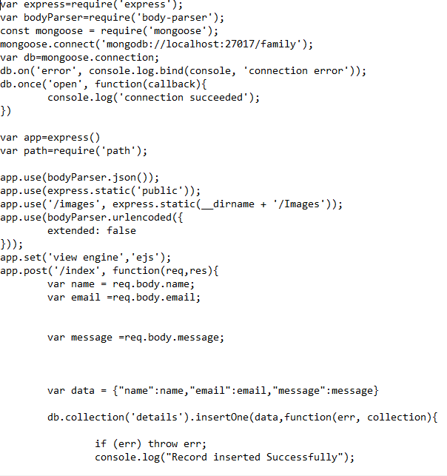

package

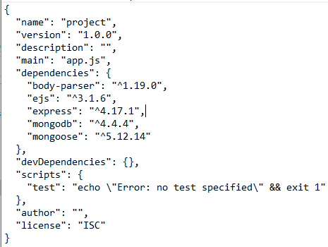

conclusion:

You now have designed your very own web page. Not only have you learned the design aspects of web development, but you have also learned how to program in HTML. Through evaluating many different web sites, you are aware of what is effective and ineffective to viewers when designing a

website too.

Through this hands-on project I was able to see how well you understood the material presented, and your critical thinking as you developed the restaurant site. You were also able to show me your creative side, through the layout and design of your project. As a team you both were able to use your problem-solving skills to troubleshoot errors when something did not work the way you intended. Knowing basic HTML is a skill that will help you with blogging, working with Wikis, Facebook, and much more.

Reference:

[www.youtube.com](http://www.youtube.com).

[www.researchgate.net/publaction/226306110_web_application._](http://www.researchgate.net/publaction/226306110_web_application_)

https://www.w3schools.com/java/.